LAB 6

Polynomial Approximation

Assignment 1:
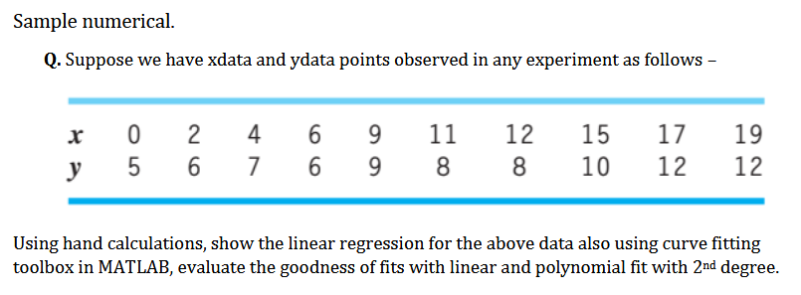

Hand Calculation: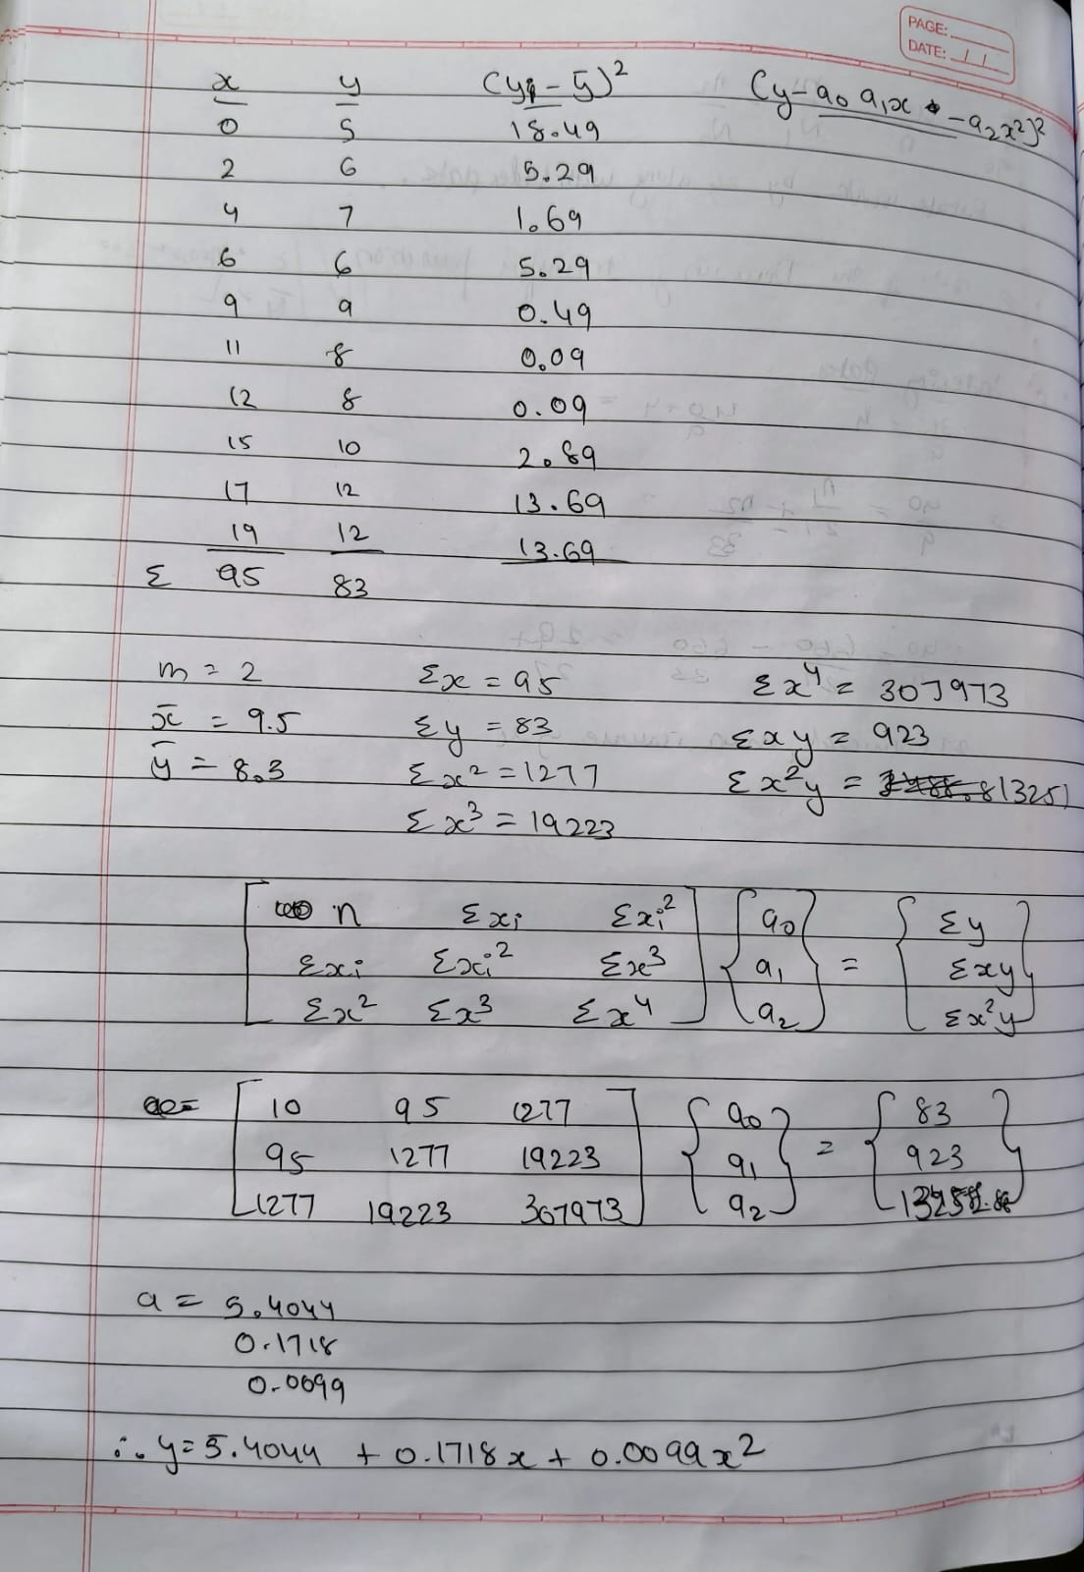
Figure 1 Hand calculation using Least square method
Matlab Code
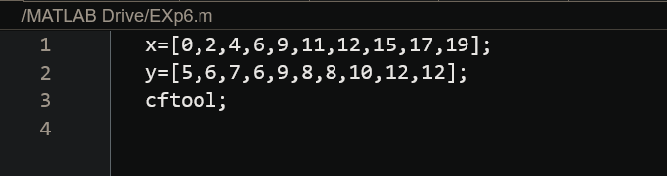
Figure 2 Matlab code for finding curve using cftool
Result
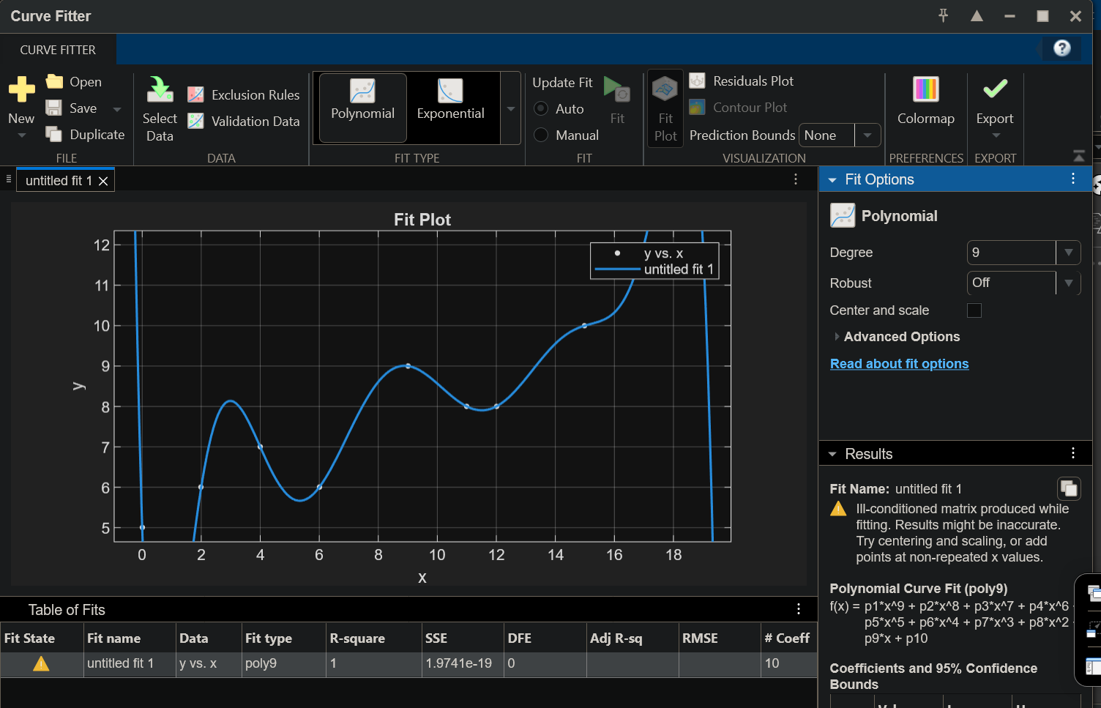
Figure 3 CF tool solution using 9 degree polynomial
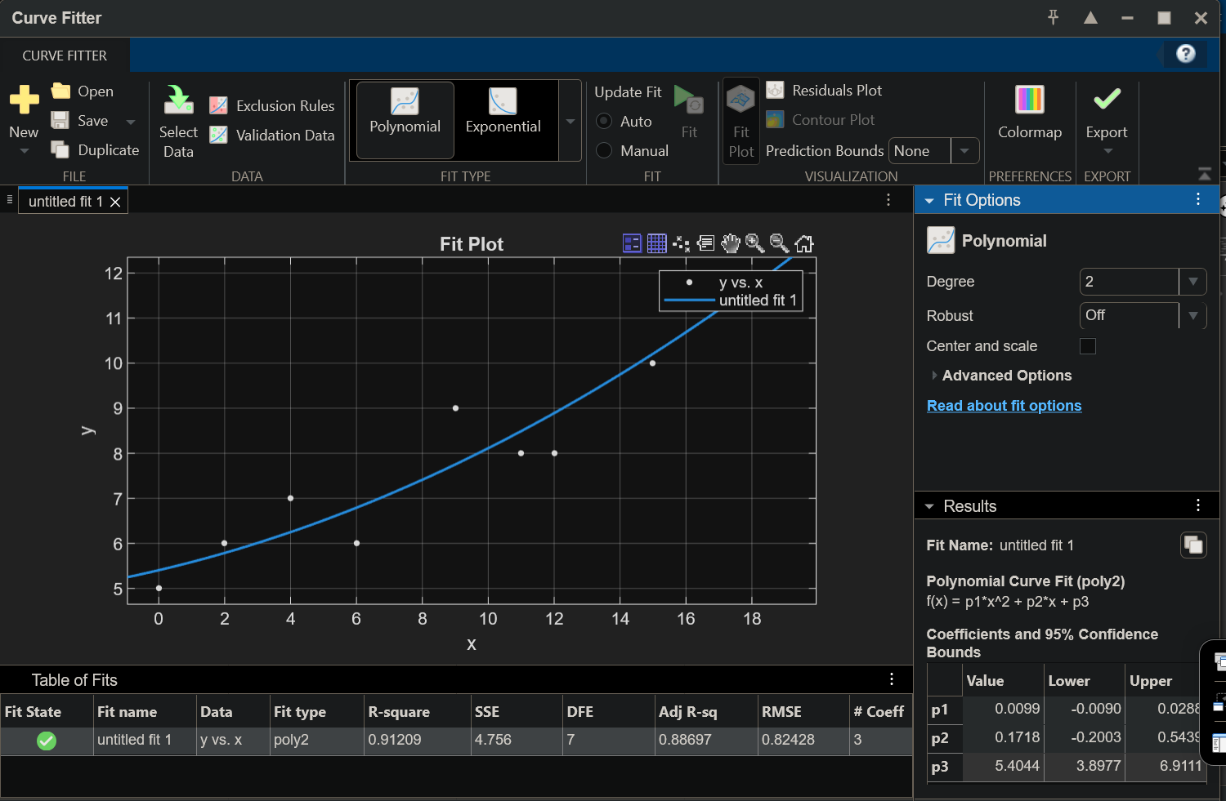
Figure 4 CF tool solution using the 2nd degree polynomial

